Safety Awareness
For Researchers in the
Giga-to-Nanoelectronics Laboratory

Richard Barber

Department of Electrical and Computer Engineering
University of Waterloo
Waterloo, Ontario

June 14, 2006

Table of Contents

Safety Training …………………………………………………….…………..……2
Emergency Contact Numbers …………………………………………….….…...3
First Aid Emergency Procedures………………………………………….………4
G2N Toxic Gas Alarm Procedures …………………………….………….………5
1 Toxic Gas Alarm Sounds……………………………………….………...5
2. G2N personnel………………………………………………….…………5
3. UW Police……………………………………………………….….…..….5
False Alarm Procedures……………………………..…………..……..…...5
G2N Laboratory Evacuation Procedures……………………………….…...…….6
Fire/Evacuation Emergency Procedures…………………………………….…….7
In Case of Fire…………………………………………………………....…..7
If You Are On Fire……………………………………………………..….….7
When Fire Alarm Sound………………………………………………..…....7
If Unable To Evacuate…………………………………………………..…...7
Controlled Evacuation…………………………………………………..……8
Exhaust alarm procedures……………………………………………………..…….9
Location of Safety Equipment…………………………………………………..….10
Fire Extinguishers………………………………………………………..…..10
Material Safety Data Sheets…………………………………………….….10
Safety Glasses…………………………………………………………….….10
Eye Wash Fountains……………..……………………………………….…10
Emergency Showers…………………………………………………..….…10
Calcium Gluconate Cream for Treatment of HF Burns………………..…10
Chemical Protection Equipment…………………………………………….10
Gas Handling Systems………………………………………………………………11
Types of gases used in G2N………………………………………………...12
General Safety Practices………………………………………….………………....13
Safe use of Chemicals………………………………………………………………..14
Hydrogen Fluoride Standard…………………………………………………………15
Chemical Exposure……………………………………………………………………17
Chemical contact with the eyes……………………………………………...17
Ingestion of chemicals………………………………………………………...17
Contact of chemicals with the skin over a large part of body……….….....17
Hazardous Materials Spills……………………………………………………………18
Waste Disposal ………………………………………………………………………..18
Other Hazards………………………………………………………………………….19
- High Voltage ……………………………………………………………….19
- Laser Radiation ……………………………………………………………19
- RF Radiation ………………………………………………………………19
- High Temperature …………………………………………………………19
- High Intensity Light Sources ……………………………………………..19
- UV light sources …………………………………………………………..19
- Moving parts ……………………………………………………………….19
- Safety Training

All lab users must successfully completed the WHMIS course, available at the University of Waterloo Safety Office website at the following location:

http://www.safetyoffice.uwaterloo.ca/hspm/chemicals/whmis/WHMIS_online.htm

Reporting Accidents

http://www.safetyoffice.uwaterloo.ca/hspm/injury/injury_reporting.htm

Reporting Equipment or facilities malfunction
http://www.safetyoffice.uwaterloo.ca/hspm/maintance/maintance.htm

Emergency Contact Numbers:

- Ambulance 911
- Fire alarm pull station for fire department
- UW Health Services ext. 3544 (office hours only)
- UW Police ext. 4911 ( 2-2222 in August)
- Spill Control ext. 4911 ( will change in August)
- Plant Operations ext. 3793 ( 3-3793 in August)
- Poison Control Centre or 1-800-268-9017 ( use the number listed in MSDS after September)

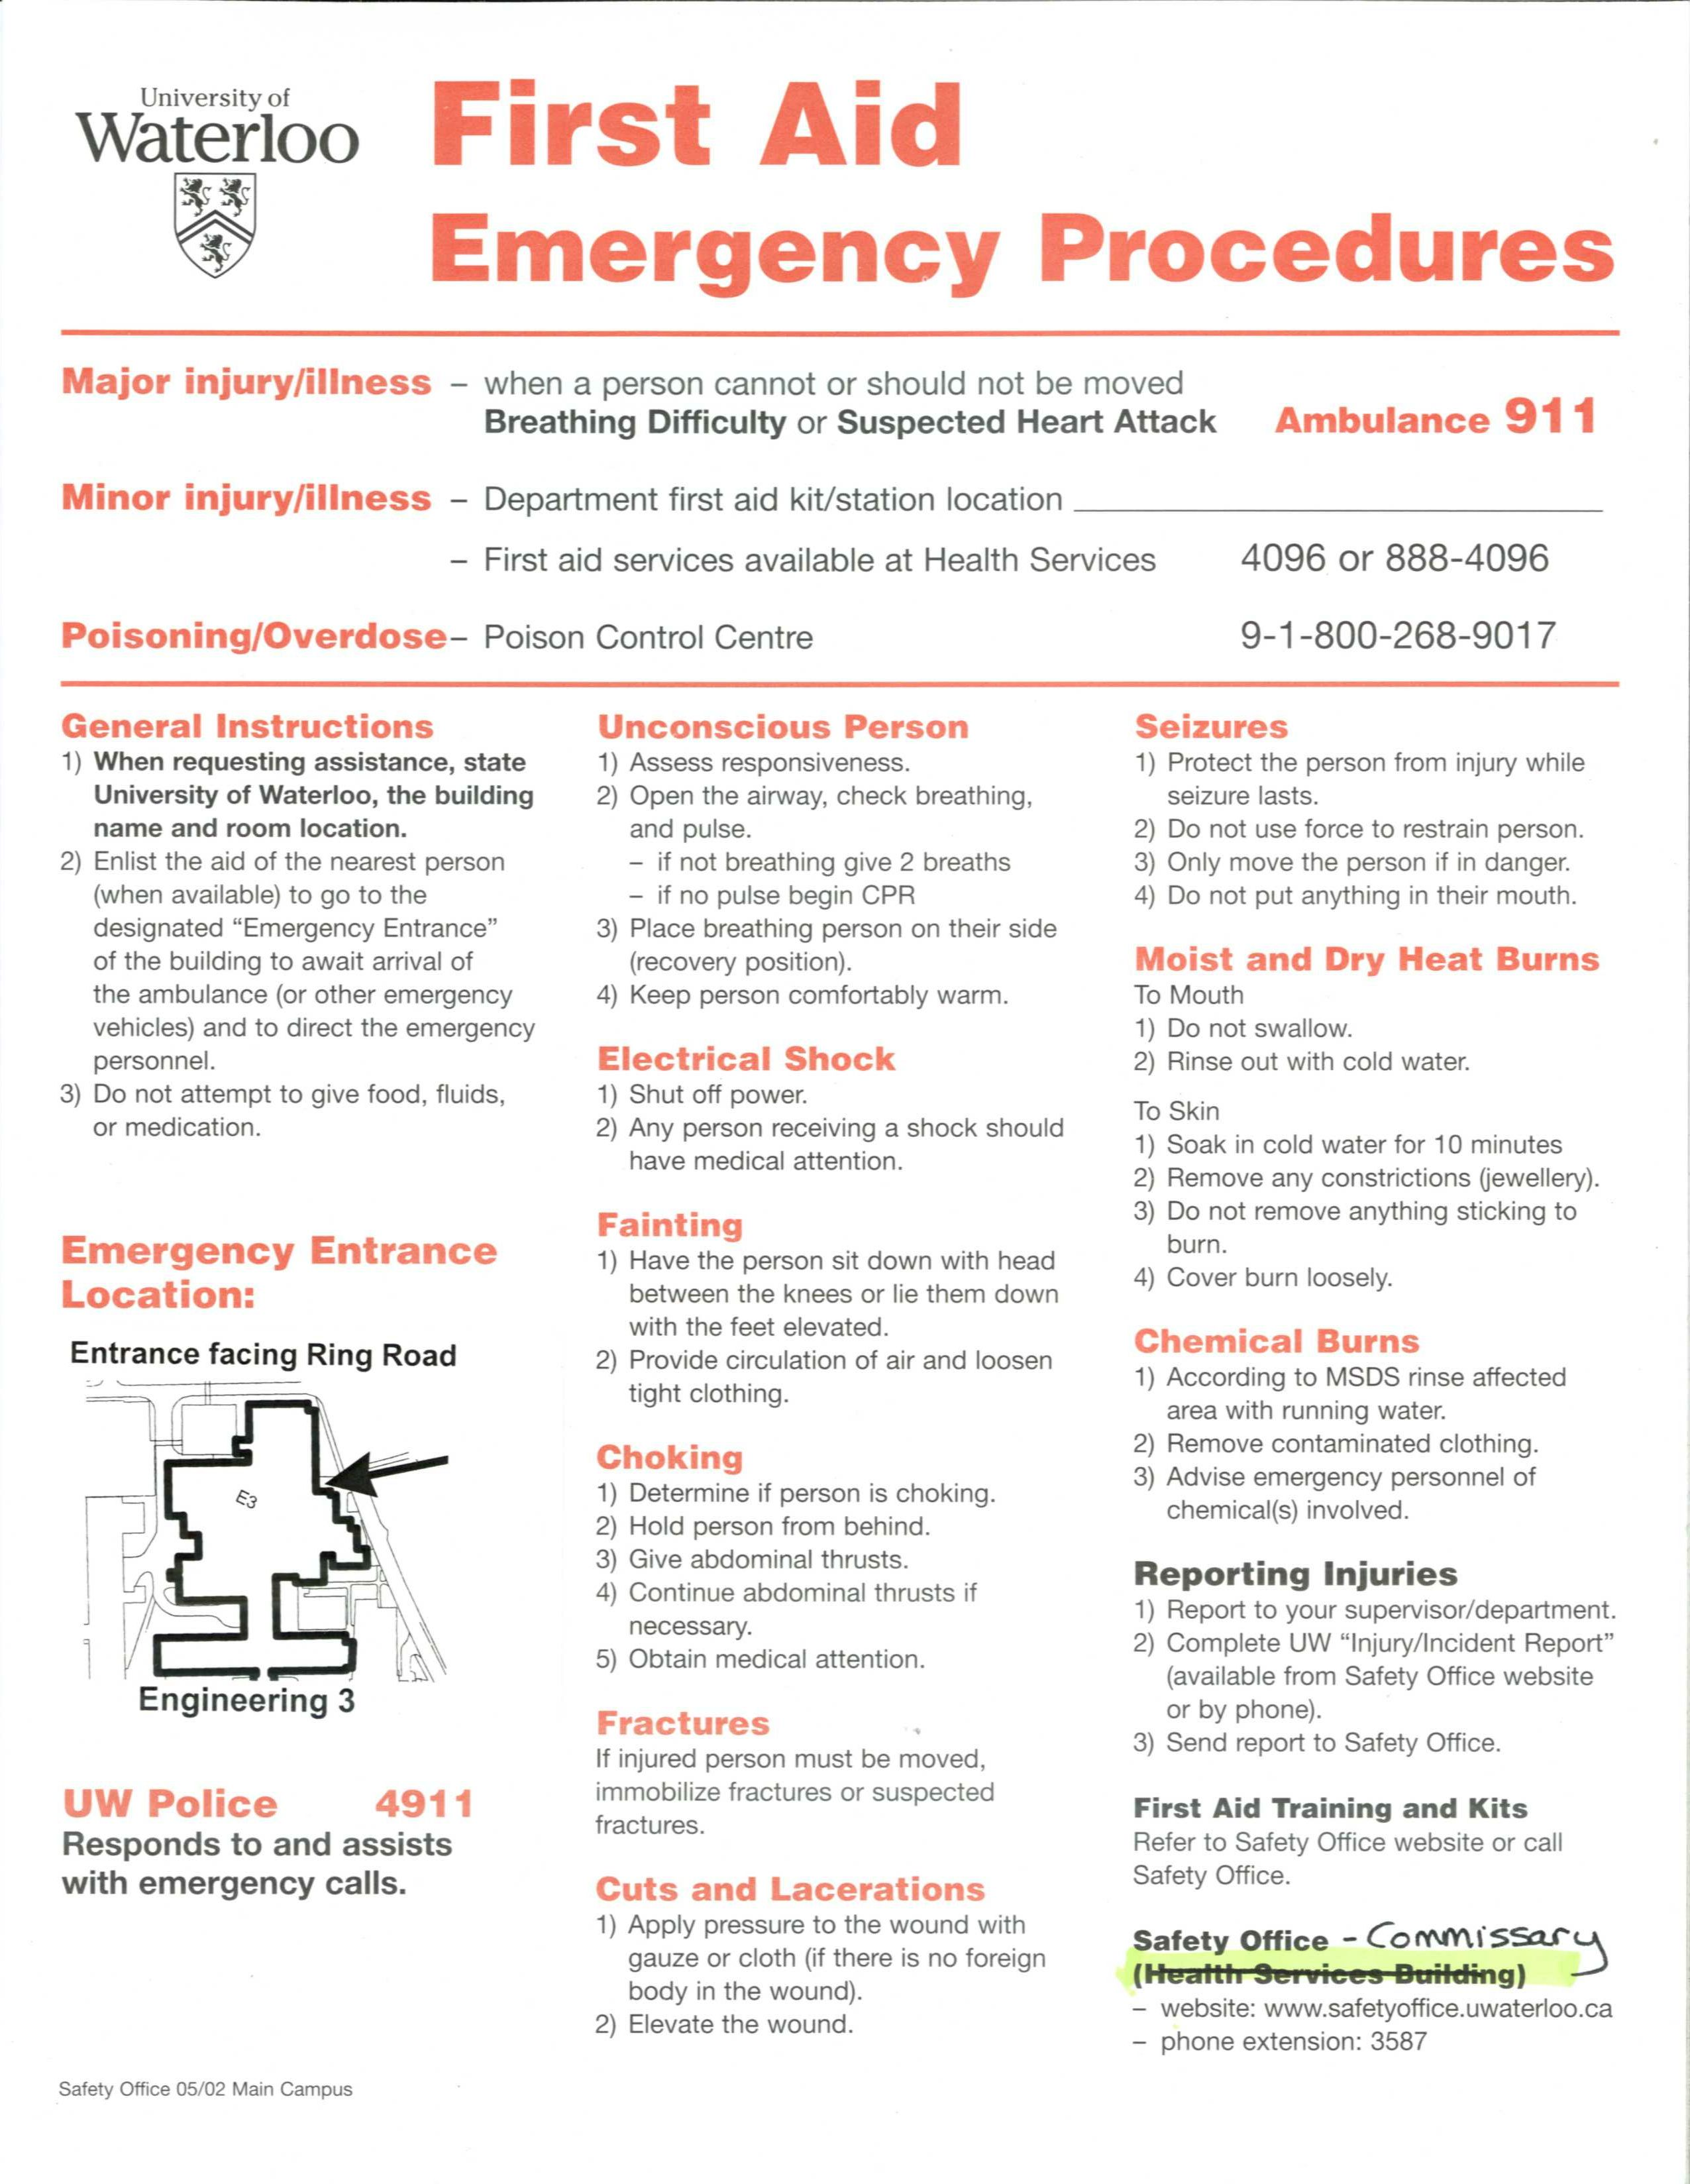
G2N Toxic Gas Alarm Procedures March 29, 2006

1. Toxic Gas Alarm Sounds
• Gas flow is terminated in all gas cabinets.
• Supply air fan for G2N is shut down
• All doors unlock
• Alarm sent to Central Plant
• Central Plant will notify UW Police (There is a gas alarm at the G2N Lab)
• UW Police will notify the following people
Contact | Home Phone | Work
a. Richard Barber | 742-8538 | Ext 3864
b. Denis Striakilev | 496-2339 | Ext 6848
c. Andre Sazonov | ( 416) 994-2381 | Ext 2863
d. Robert Mullins | 267-0510 | Ext 7097
• UW Police will proceed to the Davis Centre lobby to meet with G2N personnel

2. G2N personnel:
a. Leave via designated exits and proceed to form up area (Davis Centre lobby)
b. Contact UW Police 888-4911 or 4911 on campus phone to confirm the alarm.
c. Report to UW Police the nature and extent of the leak, a decision as to the extent of
the security perimeter can be made at this time.

3. UW Police will contact UW Spill Team / Waterloo Fire Department Hazmat Team

False Alarm Procedures
1. G2N personnel leave via designated exits and proceed to form up area (Davis Centre
lobby)
2. Laboratory manager will contact Central Plant Ext 3793 to confirm a false alarm
3. Laboratory manager will contact UW Police 888-4911 or 4911 on campus phone to confirm
a false alarm.
4. Laboratory manager will reset the Toxic Gas Alarm
5. Laboratory manager will reset door locks
6. Laboratory manager will proceed to E3 Room 1157 (foyer) and press supply air fan reset
button.
7. G2N personnel may return to lab and resume work

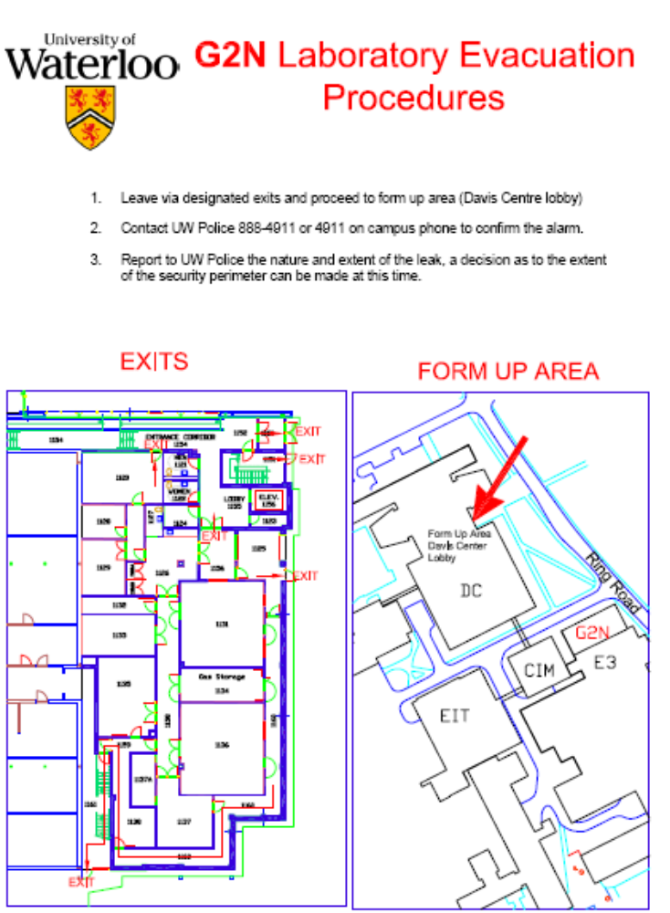

Fire/Evacuation Emergency Procedures

In Case of Fire
- Leave fire area and close doors.
- Activate wall mounted fire alarm pull station located at exits.
- Attempt to extinguish fire only if you can do it safely.
- Report any information about fire to UW Police and Fire Department.

If You Are On Fire
STOP where you are, DROP to the floor or ground and ROLL your body to smother the fire.

When Fire Alarm Sound
- Calmly evacuate the building. Do NOT use elevator.
- As time allows close windows and doors. Turn off cooking, electrical and laboratory equipment. Put on coat in winter for protection.
- Use an alternate exit, if you encounter smoke or fire.
- Follow instructions of emergency response services and fire wardens.
- Report anyone suspected of remaining in the building.
- Move away from building at least 30 metres, leaving clear access for emergency services.
- Do not re-enter the building until authorized by Fire Department or UW Police.

If Unable To Evacuate
- Call 9-911 or 911 giving your location.
- A closed door can provide good protection against fire and smoke. Use available materials to seal door and air ducts.
- If smoke enters room, stay low as heat and gases tend to rise.
- Signal your position at a window.
Persons with mobility difficulties or who use wheelchairs should move to an area of refuge (stairwell, room with phone).

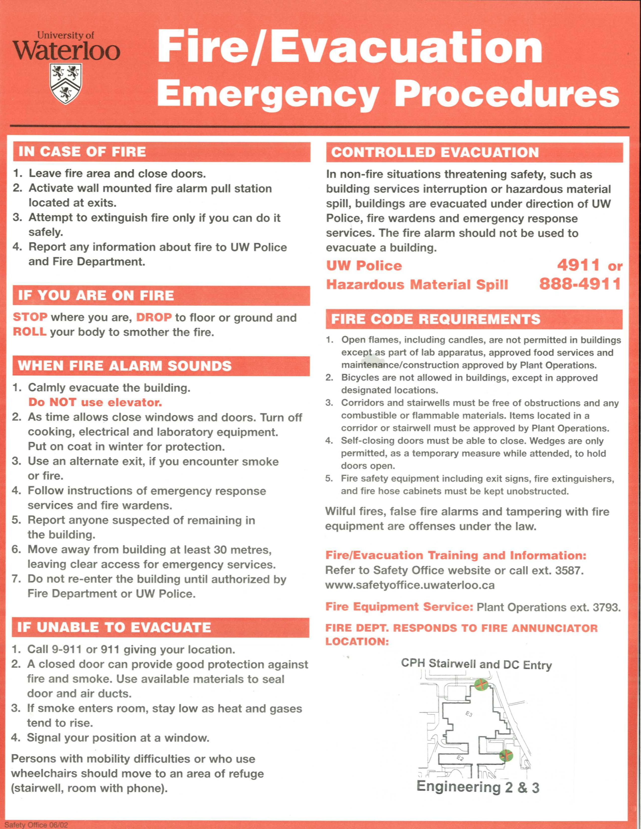

Controlled Evacuation
- In non-fire situations threatening safety, such as building services interruption or hazardous material spill, buildings are evacuated under direction of UW Police, fire wardens and emergency response services. The fire alarm should not be used to evacuate a building.

UW Police or Hazardous Material Spill 4911 or 888-4911(will change in August)

Please refer to the University of Waterloo Safety Office website:
http://www.safetyoffice.uwaterloo.ca/hspm/emergency/fire/fire_alarm_procedures.htm
Fire and Controlled Evacuation Plan for E2 and E3
http://www.safetyoffice.uwaterloo.ca/hspm/emergency/fire/evac/e3e2/e2e3.htm

Exhaust alarm procedures:

A failure of the lab exhaust system is indicated by:

- an alarm buzzer on the Mini Monitor Plus panel on top of the dangerous gas cabinets in room 1134, together with an illuminated red LED beside the “EXHAUST FAILURE” label. Typically, several gas cabinets will display this indication simultaneously.
- an alarm signal from the VentAlert sensor on the wet benches in Lithography Room 1137 or Etch Room 1137A.

In the event of an exhaust failure, IT IS NOT SAFE TO REMAIN IN THE LAB.

Leave the lab area, and notify the lab manager as soon as possible.

Location of Safety Equipment

Fire Extinguishers:

Fire extinguishers are located near the interior doors of each lab, in the service bays, and in the garb room, the storage room and the loading bay.

Material Safety Data Sheets
A library of Material Safety Data Sheets (MSDS) is maintained in the Garb Room on the counter near the sink. This currently occupies three 3-ring binders. Chemicals are listed alphabetically.

Safety Glasses:
Safety glasses are available in the garb room, and in the Etch Room (1137A) and Lithography Room (1137). Eye protection is required when working with chemicals, and is recommended when using mechanical devices (wafer spinners) or when cleaving wafers.

Safety glasses are also required when there is a danger of exposure to high intensity light sources, electric arcs (e-beam sources), plasmas and laser light.

Eye Wash Fountains:
Eye wash fountains are provided beside each of the wet benches. There is an eye wash fountain in each of rooms 1137 and 1137A.

These eye wash fountains MUST REMAIN UNOBSTRUCTED AT ALL TIMES.

Emergency Showers:
Emergency showers are located in rooms 1137 and 1137A.

Calcium Gluconate Cream for Treatment of HF Burns:
A container of calcium gluconate cream is kept above the wet bench in the Etch Room (1137A). Use this cream according to the special instructions for treating HF skin contact. Advise the lab management if you use this cream.
Seek medical attention for any HF exposure.

Chemical Protection Equipment
Neoprene rubber aprons and gloves, and face shields are kept in the etch room (1137A). These are for your protection when mixing large quantities of hazardous chemicals. It is recommended that you use this equipment whenever you are using strong acids and bases, or any highly reactive chemical.
Gas Handling Systems

The gas handling systems are maintained by Robert Mullins and Richard Barber.

Flammable, corrosive and toxic gases are contained in gas cabinets located in Room 1134.

You should NEVER adjust the pressure on the regulator panels.

The procedure for using these gases is to:
- Put your name on the gas cabinet containing the gas you will use using one of the name cards and magnetic clips available. Do this even if someone else is already using this gas.
- Make sure no alarm conditions exist on the Mini Monitor panel.
- Turn on the gas by activating the ON button for your gas on the Mini Monitor panel above your gas cabinet.
- Make sure no alarm conditions are displayed for your gas. Possible alarms are:
  - Excess flow indication
  - Overpressure indication
  - Exhaust failure indication
- If an alarm condition is present, try pressing Alarm Silence followed by Reset.
- If the alarm condition persists, contact Richard (x3864) or Robert (x7097).
- When you finish with your gas, check the names on the gas cabinet.
- If someone else is using this gas, proceed to step 10 below.
- If you are the only remaining user of this gas, turn the ESO valve off by pressing the OFF button on the Mini Monitor panel above the gas cabinet.
- Remove your name from the gas cabinet.

Other gases are located in the ‘cylinder farm’ located in corridor 1159. Check the regulator in the panel above to make sure the cylinder has enough gas to proceed. You should not need to adjust the delivery pressure on any gas in this area. Contact Robert or Richard if adjustments are required.

In a few cases, gas cylinders are located near the equipment in which the gas is used. Check that your cylinder is turned on. Open the main cylinder valve all the way, then close it about ¼ turn. Check the regulator attached to the cylinder to make sure the there is enough gas to proceed.
Types of gases used in G2N:
- Simple Asphyxiants, which can displace the air in a confined area, causing suffocation.
- Gases which support combustion, such as Oxygen and N₂O.
- Combustible gases, such as H₂ and CH₄.
- Corrosive gases, including NH₃, Cl₂ and BCl₃.
- Pyrophoric gases such as SiH₄.
- Pyrophoric and toxic gases such as PH₃, B₂H₆ and TMB.

General Safety Practices

http://www.safetyoffice.uwaterloo.ca/hspm/lab_safety/general_safety.htm

1. | Know all the safety rules and procedures that apply to your work. IF YOU DON'T UNDERSTAND - ASK!
2. | Determine the potential hazards, appropriate safety precautions and proper waste disposal techniques before beginning any new operation.
3. | Know the location and proper use of emergency equipment (safety showers, eye baths, fire extinguisher, and first aid kits)
4. | Be familiar with emergency procedures (exits, alarm stations, and evacuation routes)
5. | Do not eat, drink, smoke or apply cosmetics in any laboratory.
6. | Do not pipette or start siphons by mouth.
7. | Wash hands with soap and water before leaving the work area. This applies even if one has been wearing gloves.
8. | Know what protective equipment is available and use the proper type for each experiment.
9. | Ensure that all chemicals are correctly and clearly labelled.
10. | Use laboratory equipment only for its designated purpose.
11. | Combine reagents in appropriate order. (i.e., pour water first and then acid; and avoid adding solids to hot liquids)
12. | Wipe up spills immediately.
13. | Keep sinks clean. Practice good housekeeping and clean up at the end lab work.
14. | Keep aisles free of obstructions (chairs, stools, boxes, etc.). Apparatus set up should be as far back on bench as conveniently possible so it will not tip onto floor.
15. | Do not set up apparatus so that it is necessary to reach through the assembly to turn water, gas, or electricity on or off. Assemble apparatus so that control valves and switches will remain accessible if a fire should occur.
16. | Confine long hair and loose clothing or jewelry when in the laboratory
18. | Avoid exposures to gases, vapours, and aerosols (USE FUME HOODS)
19. | Do not leave experiments in process unattended. (If you must leave equipment running over night please post contact information near experiment)
20. | Identify shut off switches and ensure they are easily accessible.
21. | Children should not be allowed in the laboratory.
22. | Avoid working alone at night.
23. | Keep laboratories locked when unoccupied. (leave doors unlocked while working in laboratory in case assistance is needed)

Safe use of Chemicals

All chemicals must be treated with care and respect. Proper safety equipment including protective eyewear (safety glasses or goggles) should be worn whenever these chemicals are being used (even if you are not the one using them). Safety equipment such as neoprene aprons and gloves, and face shields are recommended.

Chemicals used in G2N include:
- Acids including strong mineral acids such as H₂SO₄, HNO₃, HCl and HF. Organic acids such as acetic acid are used in this area.
- Bases including strong bases such as KOH are used. Weak bases such as TMAH (MIF 312 developer) are also used.
- Solvents – in particular, acetone and propanol. Solvents such as benzene and toluene are used in G2N. Some of these have known carcinogenic properties, and should be used with appropriate protective equipment, and in a vented fume hood or wet bench.
- Hydrofluoric Acid. HF is a particularly dangerous acid. HF users need to be very aware of the hazardous nature of this material. For detailed information, YOU SHOULD READ THE FOLLOWING WEBSITES:

http://snf.stanford.edu/Safety/AboutHF.html

http://www.emedicine.com/emerg/topic804.htm

Hydrogen Fluoride Standard
From: http://www.safetyoffice.uwaterloo.ca/hspm/chemicals/hf.htm

Introduction
Hydrofluoric acid is highly corrosive and toxic even in a dilute form, therefore any contact with skin or eyes must be treated as a medical emergency. The following procedures will assist the user in the safe handling of Hydrofluoric acid. Further information is available from the Safety Office.
Personal Protective Equipment:
- The following equipment is to be used when handling hydrofluoric acid:
- Eye and face protection as appropriate (approved splash goggle or a full face shield).
- A splash apron.
- Gloves (neoprene or nitrite rubber).
- Fume hood (plastic Sash Window).
- Eye wash station / full body shower.

First Aid:
All laboratories using hydrofluoric acid must have:
- Hydrofluoric acid burn cream (2.5 % Calcium Gluconate in Muko gel) available from Chemistry Stores (ESC 109).
- An approved eye wash.
Skin (Large Burns)
- Treat as medical emergency-call ambulance immediately-dial 911.
- Rinse affected area until ambulance arrives (protect eyes from contamination and remove contaminated clothing.)
Skin (Small Burns)
- Rinse affected area for 15 min. with water and then apply burn cream liberally to affected area.
- Get medical aid (Health Services, Family Physician or Hospital).

Eyes (any amount)
- Treat as medical emergency-call ambulance immediately-dial 911.
- Rinse eyes with water until ambulance arrives.

Ingestion
- Treat as medical emergency-call ambulance immediately-dial 911.
- Rinse mouth liberally with water.
- Do not induce vomiting.

Inhalation
- Treat as medical emergency-call ambulance immediately-dial 911.
- Remove victim to fresh air.
- If breathing stops rinse acid from mouth and administer artificial respiration

Chemical Exposure
Chemical contact with the eyes:
- Take victim immediately to the nearest eyewash station.
- Flush the eyes for at least 15 minutes.
- Eyelids must be held open with the eyeballs continuously rotating for optimum flushing.
- Call UW Health Services ext. 3544. The medical staff will assess the situation and arrange for further medical treatment. Further medical attention is required whenever an eye wash station is used.
Ingestion of chemicals:
- Call 911 or transport to hospital
- Call the Poison Control Centre or 1-800-268-9017 for advice on first aid.
- Do not induce vomiting unless specifically instructed to do so by trained medical personnel.
- Call UW Health Services ext. 3544(during regular office hours). The medical staff will assess the situation and arrange for further medical treatment.
Contact of chemicals with the skin over a large part of body:
- Help the injured person to the safety shower, and flush the exposed skin for at least 15 minutes*. Remove a person’s goggles only after washing their head. If the eyes are also involved, have the person bend over to flush their eyes while the shower is running.
- Enlist the assistance of a staff person or a student of the same gender as the injured person. Generally, it is helpful to have three or four people assisting the victim.
- For the removal of contaminated shirts or sweaters, avoid contaminating the face and eyes of the victim by cutting the clothing so it may be pulled away. Remove all layers of contaminated clothing, shoes and jewelry.
- If clothing or jewelry adheres to a chemically-burned area of skin, do not pull it away.
- Call UW Health Services ext. 3544. The medical staff will assess the situation and arrange for further medical treatment. Further medical attention is required whenever a safety shower is used.

*The procedure for HF skin contact is different: For HF contact, flush the exposed skin for 5 minutes. Then apply calcium gluconate cream (located above the wet bench in room 1137A). Seek medical attention for any skin contact with HF or buffered HF solutions. Exposures involving areas larger than 10% of the skin surface shoulsd be treated as a medical emergency. Call 911. Rinse the victim with copious amounts of water while waiting for the ambulance to arrive.

Hazardous Materials Spills
http://www.safetyoffice.uwaterloo.ca/hspm/environmental/spills.html
Follow these procedures for biological, chemical and radioactive materials.
Prior to work with hazardous materials:
- Determine spill procedures from MSDS for all chemicals.
- All UW employees and students handling hazardous materials are required to be trained in spill procedures.
- Obtain proper spill kits and clean up equipment. Available from Chemistry Stores ESC 109.
Small spill that poses no immediate threat to health:
- Notify occupants in the immediate area of the spill
- Use spill kits to absorb and contain according to spill procedure.
- Place material in a secure and ventilated area
- Contact Safety Office at Ext. 6268 for disposal instructions.
Large spills or spills that pose an immediate threat to health:
- Remove sources of ignition if possible
- Evacuate immediate area
- Call UW POLICE x4911
Contact UW Safety Office Ext. 6268 with any questions or for assistance.

WASTE DISPOSAL

All chemical, biological and radioactive wastes are to be disposed of at the ENVIRONMENTAL SAFETY FACILITY located on the first floor of Earth Sciences and Chemistry (ESC) Rm. 150. Material may be delivered to the facility Monday to Friday from 11:00 A.M. to 12:00 Noon or a pickup may be arranged by calling Ext. 5755.
University policy requires compliance with environmental regulations.
Do not put any hazardous materials in the regular garbage or into the drains.

Other Hazards

- High Voltage – high voltage sources and connections are generally in enclosed cabinets. Do not attempt to defeat interlocks, or expose hazardous electrical circuitry.
- Laser Radiation – laser radiation sources are present in the G2N facility. Do not attempt to operate laser equipment without proper protective equipment, including eye protection rated for laser radiation. Make sure all personnel in the area are protected.
- RF Radiation – several pieces of equipment in G2N use RF sources. These generally operate at 13.56 MHz. Such radiation is not known to cause serious biological effects. Nevertheless, direct contact with RF sources and connections can result in burns and tissue damage. Avoid direct contact with operating RF connections.
- High Temperature – the G2N lab contains a number of ovens, hot plates and heated chambers. Care should be exercised in the use of all heated equipment.
- High Intensity Light Sources – intense visible radiation can be observed from lamps on photolithography equipment, RTA’s, e-beam sources and plasmas. Avoid long exposure to these light sources. Use appropriate protective eyewear if you need to look at or near such sources for extended periods.
- UV light sources – the mask aligners use high intensity lamps which radiate in the UV spectrum. Eye protection rated for UV must be used when working near such light sources.
- Moving parts – mechanical moving parts are generally protected by guards. Do not attempt to defeat these guards, and do not leave moving parts exposed.

